Inglés I
Bloque 2
Nombre: _______________________________________________ Grupo: _______________
Responde correctamente los siguientes ejercicios.
- Si requieres de ayuda puedes consultar las siguientes ligas en internet: www.agendaweb.com y http://web2.uvcs.uvic.ca/courses/elc/studyzone/
Look at the images and find what country is it.
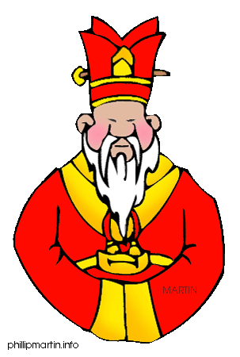 | 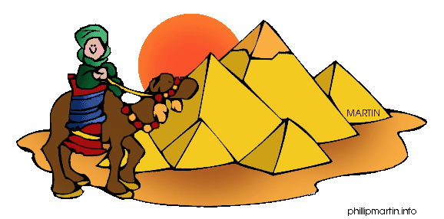 | 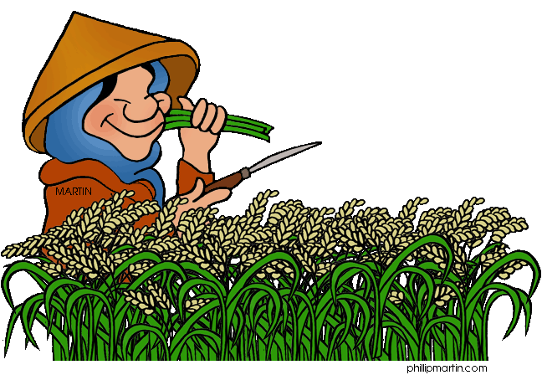 | 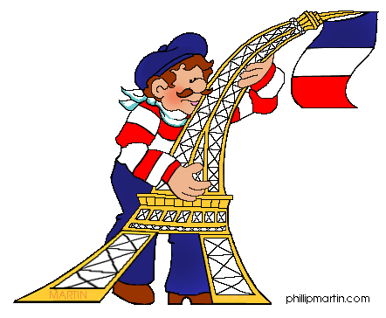 | 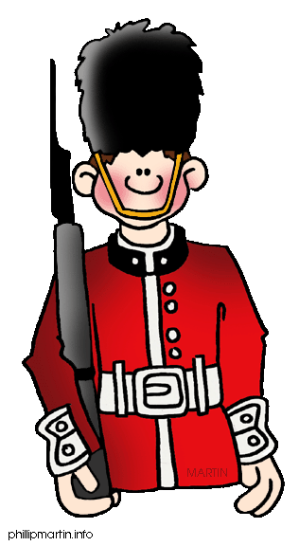 | 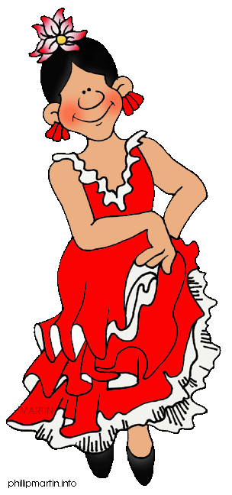
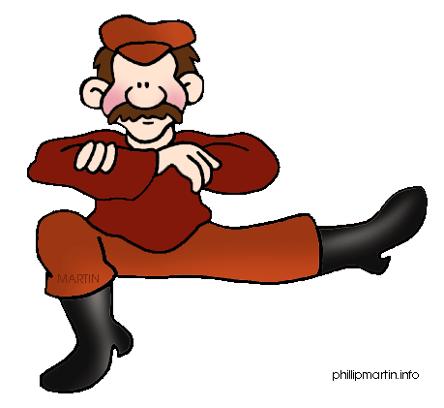 | 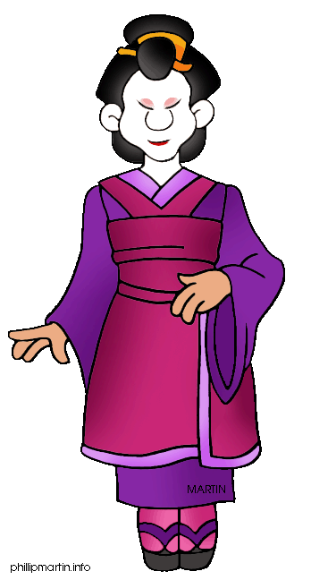 | 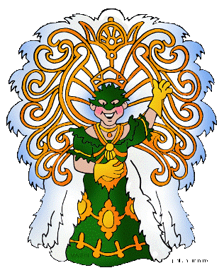 | 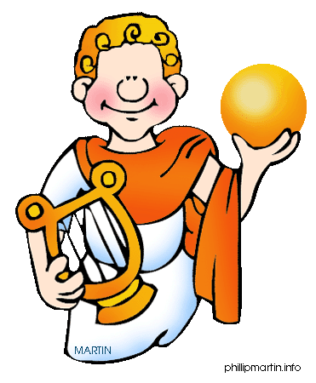 | 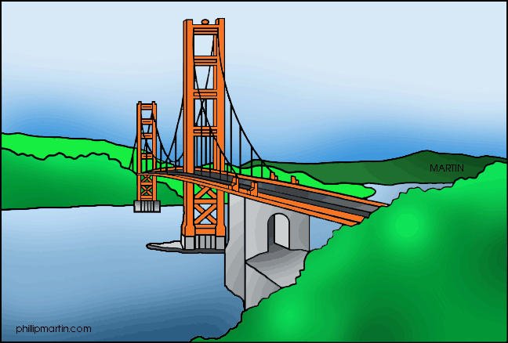 | 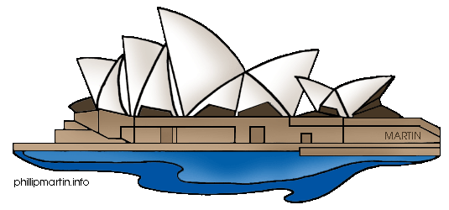

Find 11 nationalities and write them below the countries

Find the occupations
- This is a person who acts in a movie or play.
- This is a person who assembles components.
- This is a person that assists patients
- This is a person who helps doctors with their work.
- This person bakes cakes and bread
- This person cleans schools, banks, hospitals, etc.
- He or she cooks at the restaurant.
- This person delivers pizzas, and other kind of fast food.
- This person designs buildings.
- He or she teachers subjects at school.
- He or she drives a taxi.
- He or she files documents at the library.
- This person flies an airplane.
- This person grows vegetables.
- He guards buildings.

Fill in the article >a<, >an< or >the< where necessary. Choose >x< where no article is used.

1) I like ______ blue T-shirt over there better than ______ red one.
2) Their car does 150 miles ______ hour.
3) Where's ______ USB drive I lent you last week?
4) Do you still live in ______ Bristol?
5) Is your mother working in ______ old office building?
6) Carol's father works as ______ electrician.
7) The tomatoes are 99 pence ______ kilo.
8) What do you usually have for ______ breakfast?
9) Ben has ______ terrible headache.
10) After this tour you have ______ whole afternoon free to explore the city.

A) Complete the following exercise with a / an or the articles. Leave blank if no article is needed.
According to National Weather Service, cyclones are areas of circulating winds that rotate counterclockwise in Northern Hemisphere and clockwise in Southern Hemisphere. They are generally accompanied by some kind of precipitation and by stormy weather. tornadoes and hurricanes are types of cyclones, as are typhoons, which are storms that occur in western Pacific Ocean. hurricane is cyclone that forms over tropical oceans and seas and has winds of at least seventy-four miles hour. hurricane rotates in shape of oval or circle. hurricanes can cause great environmental damage. Hurricane Andrew, which hit coasts of Louisiana and southern Florida in August 1992, caused extreme devastation. In terms of environmental damage, Hurricane Andrew is one of most devastating hurricanes ever to hit United States. Fourteen people died because of Andrew's effects.
- My sister is my father's ______________________.
- My brother is my mother's ______________________.
- My ______________________ is my mother's sister.
- My ______________________ is my brother's daughter
- My ______________________ is my brother's son.
- My sister-in-law is my brother's ______________________.
- My brother-in-law is my sister's ______________________.
Unscramble the family members
1) fathre - ______________________.
2) osn - ______________________.
3) rbthoer - ______________________.
4) sesitr - ______________________.
5) othemr - ______________________.
6) necul - ______________________.
7) aarndgfther - ______________________.
8) atnu - ______________________.
9) nriachgdld - ______________________.
10) agdtuehr - ______________________.

- Write these words in plural. Add -s,-es, -ies, -ves
a boy - | a pencil- | a peach- | a potato-
a box- | a baby- | a table- | a bus-
a city- | a dish- | a robot- | a knife-
a girl- | a fox- | a toy- | a tomato-
a dress- | a beach- | a lady- | a monkey-
a bench- | a brush- | a snake- | a door-
a bike- | a desk- | a pen- | a tree-
a story- | a body- | a glass- | a way-
a leaf- | a key- | a cherry- | a duck -
a day- | a chair- | an egg - | a wish-

